Business Plan Template
[Date of last update to plan]

Introduction
[Business Owner’s Name]
[Business Owner’s Address]
[Business Owner’s Web Address]
[Business Owner’s Phone]
[Business Owner’s Email]

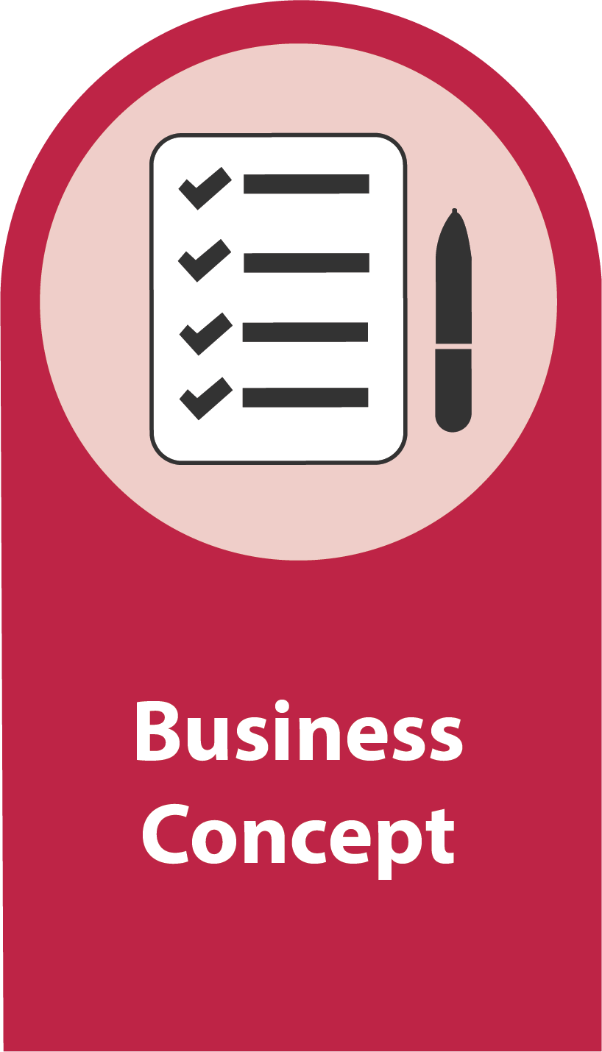
Business Concept
[In five sentences or less, describe your business. Close with a strong statement about why this business is a good investment overall. After you finish the rest of your business plan, edit the executive summary to ensure it is an accurate and compelling summary of the component parts of the plan.]

Tips & Resources
Business plan overview and checklist

Entrepreneur’s Bio

Biographies
[Describe who will manage the ongoing operation and maintenance of the business. Include brief biographies of all relevant people and describe in detail their relationship to the business. What tools and systems are in place to oversee the finances for the business? What makes you uniquely suited to start and run this business successfully? Do you have experiences, qualities or assets that will help people understand why you started this business? How is your management team uniquely suited to complete this project? Attach full resumes for the principal people involved in managing the business.]

Tips & Resources
Biography worksheet

Personal Resources
[Describe the financial situation of the proposed principal individual responsible for the business in detail. Include a complete personal financial statement (PFS) showing assets, liabilities and net assets. In addition, include a summary of relevant income and expense to show net income. Attach a complete PFS and a monthly budget of personal income and expenses. Include any and all additional information necessary to completely understand the business owner’s financial position and the future risks and opportunities for the business owner. If the business owner is a corporation, also include recent complete financial statements (preferably audited), including a balance sheet and profit and loss statement. Attach any supplemental information (such as the financial statements, audit or income and expense statements) as exhibits to the business plan. Be complete and truthful, but also persuasive, in describing how the business owner’s financial position creates a sturdy foundation to sustain the business and displays the business owner’s acumen in managing finances efficiently.]

Tips & Resources
Personal Financial Statement Instructions
Personal Financial Statement Template
Operation Hope (free personal finance coaching)

Values and Anchors
[What are your personal values that drive you to open and run your business? How do your values influence the actions that you take in running your business? What is your vision for your business? Your vision describes a future state where your dreams for your business has come to life. It flows from your core values and helps others to see where you intend to take your venture. What is your mission statement? Your mission statement captures what your company will do to reach its vision. The vision statement is a static mental picture of what you want to achieve, the mission statement is a dynamic process of how the vision will be accomplished. Statements of vision and mission should be simple, concise and easy to remember. When you’ve written your vision and mission, ensure that it meets all the following requirements: 1) clear and concise, 2) free of elaborate language, 3) distinctively yours.]

Tips & Resources
Values, Vision and Mission worksheet

Market Analysis

Industry Trends
[Describe what you have learned about your business type or industry. Do you have information about your industry from publications, interviews, observations, trade associations, banks, business owners, studies, publications or prior experience? Describe how your business plan responds to industry realities and trends.]

Tips & Resources
Trade Association Directory
UGA Small Business Development Center (SBDC), Macon office

Market Data
[Who, exactly, will be the target market for your service, merchandise or product? If there are professional market studies addressing part or all of your proposed business, summarize the market studies and describe very precisely how your business plan adheres to the recommendations in the study. Provide citations to any and all reference materials so that your reader can find and review the source materials. If there is not a market study available, you must perform your own market research. Can you gauge the sales at similar businesses by counting customers and estimating what each customer spent? Research national, regional and local trends to bolster your case.]

Tips & Resources
Downtown Macon Commercial and Residential Market Analysis
American Community Survey
Market Scan worksheet

Market Differentiation/Competitors

Competitors
[Are there similar businesses that already exist? How will your pricing strategy compare or contrast with these existing businesses? Describe your competition. If there is no competition, explain why you will be first to market with your business. Also reference other areas where your business type exists among competition. Compare and contrast your business with the existing competition.]

Tips & Resources
Competitor worksheet

Competitive Advantage
[How you will differentiate your business from this competition. What gives your business a competitive advantage? What makes your business unique? Are there unique attributes of your business’s location, marketing, merchandising, manufacturing process or management that will make it stand out in the market? Do you have a way to produce or acquire your product less expensively than your competition? Can you price your product or service higher than your competition, and if so, why do you think your business can charge a premium?]

Sustaining Advantage
[If possible, project how your business will be positioned to respond to changes in the marketplace after it is launched and as new businesses are brought on line to compete. If your business is unique because of a new process, product or system, do you have control over the intellectual property that differentiates your business? If so, explain exactly what type or protection you have obtained (trademark, patent, etc.). If not, explain your strategy for protecting your intellectual property? What makes your business durable, resilient and valuable? What is your process and plan to respond to changes, both within the business and the marketplace where it competes?]

Customer & Reach

Customer
[Who will spend money with your business? Describe the demographics of your target market, research characteristics of these demographics and describe how your business has been designed to attract and retain these demographics. Is there demographic information available from the US Census that you can use to apply market data about your industry to the neighborhood or city where you plan to operate?]

Tips & Resources
Customer identification worksheet

Marketing
[What is your plan for acquiring customers and/or clients? How will you introduce people to your business? What will you do to keep customers coming back? What is your budget for these activities and how will you fund this budget both up front and on an ongoing basis? Is your marketing plan designed to target your potential customers and clients as efficiently as possible? How successful does your marketing plan have to be to achieve your revenue projections? For instance, if you target demographic consists of 1,000 households within 3 miles of your proposed location what percentage of these households will you have to acquire as customers and clients, how often will they have to visit, and what will they have to spend on average?]

Tips & Resources
Mercer Innovation Center
SCORE Mentor
BaNC at Washington Library

Product Development & Pricing

Products and/or Services
[What specific products or services will your business offer for sale? How much will each product or service cost for the consumer to purchase? How will these products or services be merchandised or sold? Provide a complete price list, menu or services list.]

Tips & Resources
Product Profile worksheet
Customer smile worksheet

Profitability
[What are the costs for you to acquire, market and sell your product or service? How much time does it take to prepare products or render services for sale? What are the costs for every step in the process? Do you have extra expenses for packaging, delivering or distributing these products or services? Do you use any type of equipment that is necessary to deliver these products or services? Will you need to replace this equipment, and how much will it cost? After you figure out every component cost, how does your cost compare to the money paid by your customers listed above? Are these products or services profitable?]

Tips & Resources
Costing worksheet

Financials

Assumptions
[How did you estimate your sales? How many customers or clients will you have to serve on a daily, weekly and annual basis to achieve these sales? How much will these clients or customers have to buy or spend to meet your income estimates? What are the expenses that you will incur to run this business? How did you find or estimate the expenses that will be required to operate the business? Which of your expenses will rise as your business grows and which expenses are fixed? How accurate do you believe your assumptions are, and why do you believe in that level of accuracy?]

Tips & Resources
Success metrics worksheet

Operating Projections
[Summarize the income, expense and net operating income (profit) for the project. Make sure your estimates match the financial projection that you will include as an attachment. Describe the types, uses, features and characteristics of the services or products that you will offer. Describe the expenses that will be borne by the owner/operator. What will or could constrain your growth? What are the threats and opportunities on both the income and expense site of your business? Attach a complete financial projection detailing all of the income and expenses that you expect in your business for the next five years.]

Tips & Resources
Financial Projection Templates:
- Bar/Entertainment
- Restaurant
- Retail
- Service

Operations & Management

Form
[Describe the type of legal organization, whether a sole proprietorship, limited liability corporation, S-corporation, C-corporation, non-profit, partnership, limited partnership, limited liability partnership, etc. Also describe who will be members, managers and/or owners of the business and what role each owner will play. Clearly state whether the legal organization has already been formed and if not, state who, when and you intend to form the organization. Describe whether the business is a start-up, acquisition or expansion.]

Type
[Describe the type of business, whether merchandising (retail), manufacturing or service.]

Hours & Location
[Describe what the hours for the business will be and who will actually be responsible for operating the business during these hours. Describe the location you have selected for the business, and describe what the location is especially well-suited to the business. Clearly state whether you have control over the location. If you do not have control, state your strategy and timeline for gaining a lease- or purchase-option, lease, contract or letter of intent. If you do have control of the location, describe the terms and timeline for occupying the space. If you are still looking for a potential space, clearly state the requirements and preferences for securing a location that can make the business successful.]

Development & Expansion

Budget
[Describe the proposed sources and uses for starting, acquiring or expanding the business. Where will the money come from to complete the project and how will those funds be used? What is the justification for these estimates? Attach a complete financial projection explaining the development process for the business. If you have quotes, contracts or pricing estimates, attach these to your business plan to verify the expenses that you estimate for developing the business.]

Tips & Resources
Start-up budget worksheet

Development Team
[Describe the team that will be involved in the development of the business, including all outside consultants or contractors such as the architect/designer, engineer(s), construction manager or contractor, suppliers, lawyer(s), accountant(s) and any other entity or person who will be necessary to complete the project as you outline. Attach biographies and/or resumes for the key players in this process. Describe how this team will work together and who will manage the various contractors and consultants.]

Timeline
[What is the timeline for developing the business? When do you expect the business to be up and running?]

Need
[What obstacles still exist to completing the project as you have outlined? Do you need a loan or investment? Describe any and all of your outstanding needs and the terms on which you would like for these needs to be met. For instance, if you are seeking a loan, include your preferred rate, term and describe the type and value of the collateral you propose. Include the debt coverage ratio (DCR) and loan to value ratio (LTV) of the financing. If you are seeking an investor or guarantor, describe the exact needs from this investor and the kind and amount of return. Describe very quickly how, when and how much the investor gets back as returns and how this compares to the amount of investment and risk.]

Summary
[Close with a summary of the salient points from your business plan and the most persuasive attributes of your project. Restate your needs clearly, and tell your readers how to respond to those needs. For instance, explain whether email, call or text and specify what contact information to use to finance or invest in this project.]

Exhibits
[Attach any and all of the relevant materials to back up the statements and assertions in your business plan. Below, are some suggested documents that are usually included in a business plan. Make sure you attach copies of every document referenced in the business plan. Items in bold are generally required, even in initial applications for loans or investments.]

- Illustrations of your product or service
- Control of business location (contract, option, letter of intent, lease, etc.)
- Government compliance or feasibility (business license, zoning compliance, permits, etc.)
- Architectural and/or Design Drawings (As-built and As-finished)
- Market Study or analysis
- Resumes for key management
- Personal financial statement
- Personal income/expense statement
- Corporate financial statement (balance sheet)
- Corporate income/expense statement (profit and loss statement)
- Start-up budget
- Quotes from contractors, consultants and/or suppliers
- Resumes or bios for contractors, consultants and/or suppliers
- Five- or Ten-year Financial Projections (Pro Forma)
- Existing Loan/Financing/Investment Commitments

